Yoseph A Kebede

Dr. Reza Monfaredi

ENPM662 – Intro To Robotic Modeling

Fall 2022

Final Exam

**Final Exam Answer Sheet**



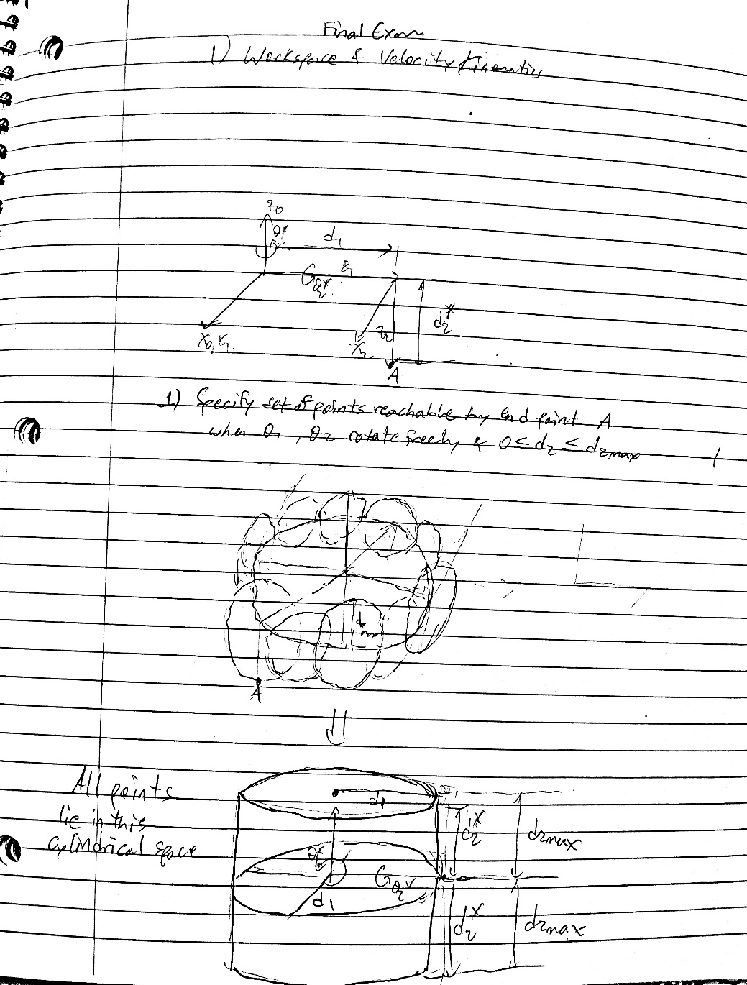

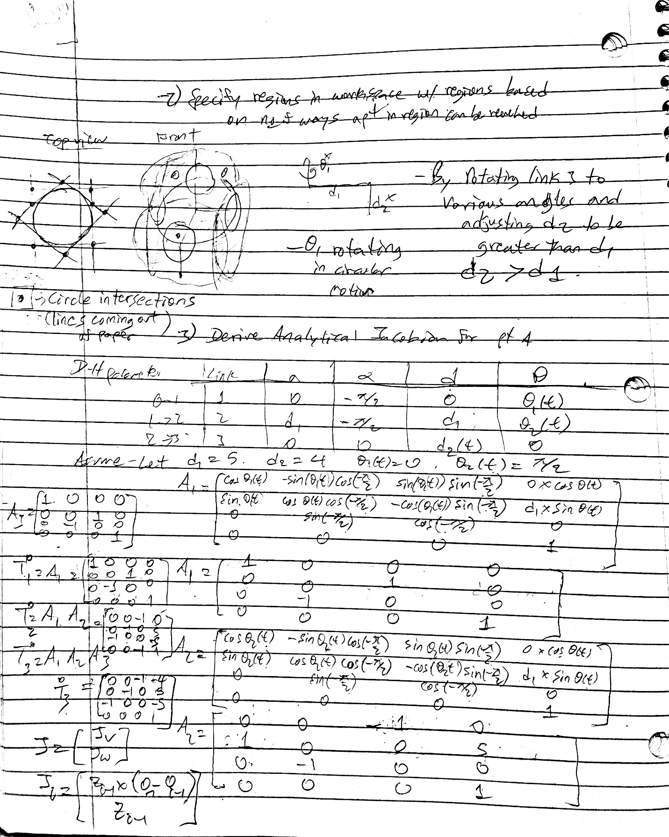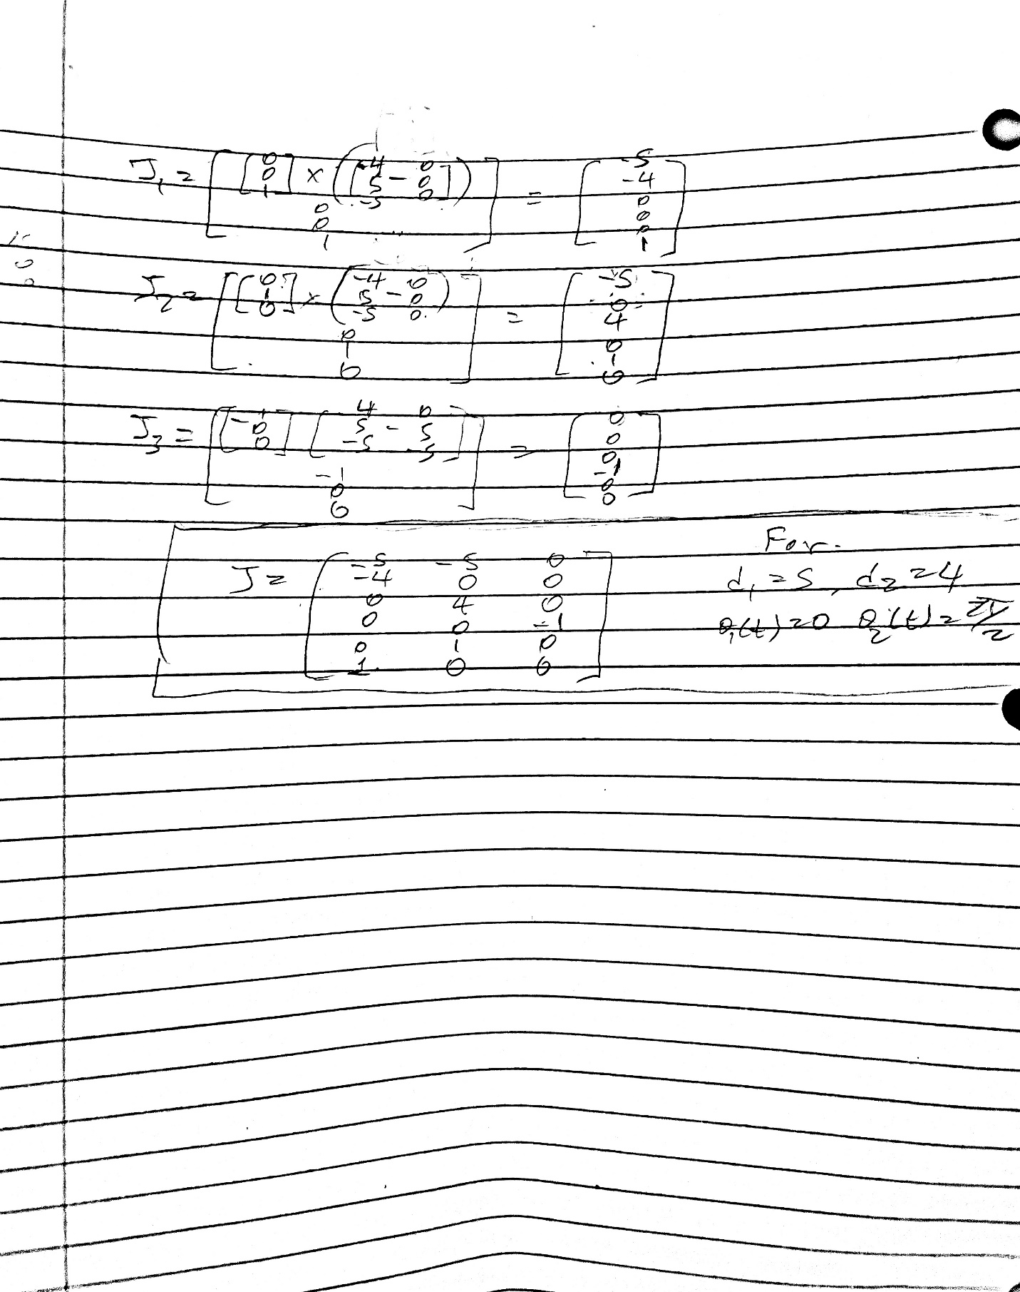

**2. 3D-3D Registration**

**Write a python code to estimate the 3D rigid transform that will optimally align the corresponding points in a set. Briefly describe your steps in the report as you Tabulate each of these transforms H, along with the mean error after aligning the point clouds i.e., 1 N PN i=1 ||x ′ i − Hxi ||.**

First, the three datasets are saved as a list and read into arrays as data sets.

Therefore, since each dataset contains 2 arrays holding points for the two-point cloud in each dataset, a total of 6 arrays are saved storing the 6-point clouds used as a comparison.

Then, by looping through each of the datasets, the below steps are followed to find the mean error for the aligning the points cloud.

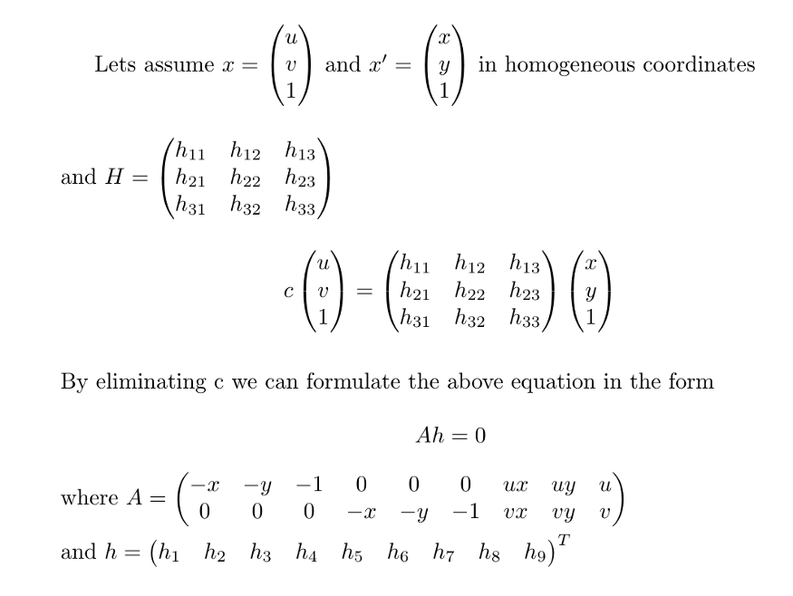

Fig 1 How to find Homography[1]

1. The z coordinate for each data set is normalized such that homogenous coordinates are obtained as shown in figure 1 above, i.e. X = [x/z, y/z, 1] and X’ = [x1/z1, y1/z1, 1]
2. Then, the matrix A was created by following the formula in figure 1 above.
3. After obtaining the A matrix, SVD(A) is calculated via

SVD(A) = U E VT

U = A AT

V = ATA

Minimum Eigenvalue = min eigenvalue (V)

H = SVD(A) = eigenvector with smallest eigen value

1. H is reshaped into (3,3) matrix
2. The mean error used to align the point cloud is computed by:

* Multiplying the original point set with the homogenous matrix
  + H * x
* Then the squareroot of mean error is found for each point in the sets, then averaged
  + 

Thus, by performing the above 5 steps on each of the remaining datasets, the mean error is computed.

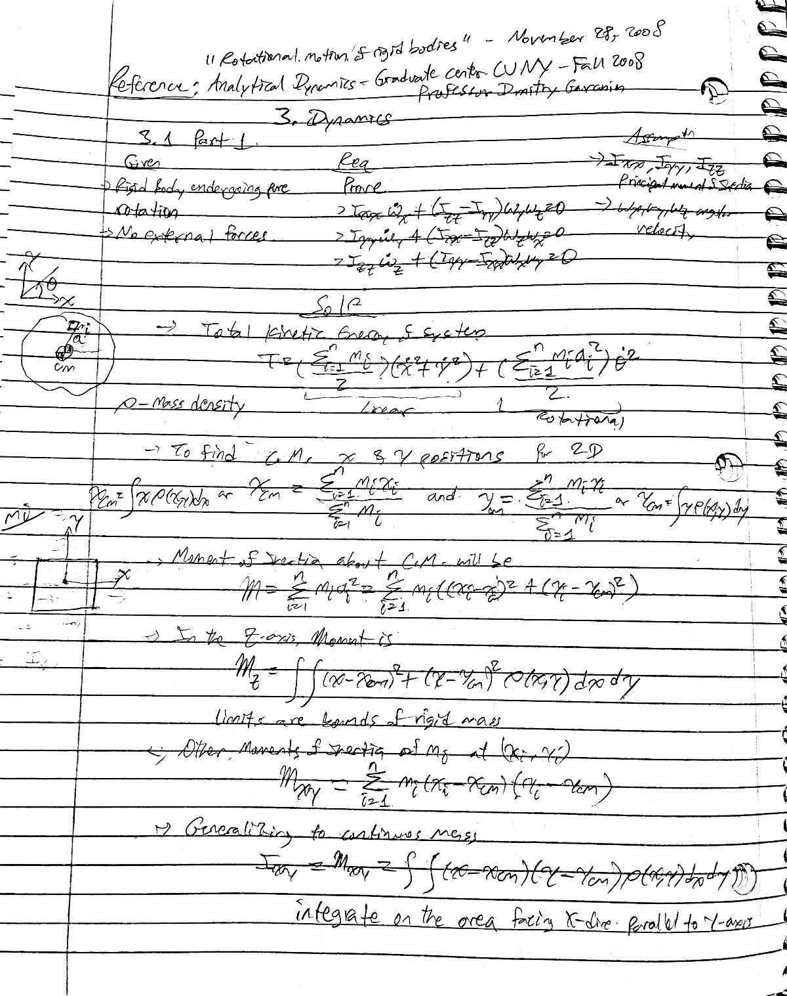

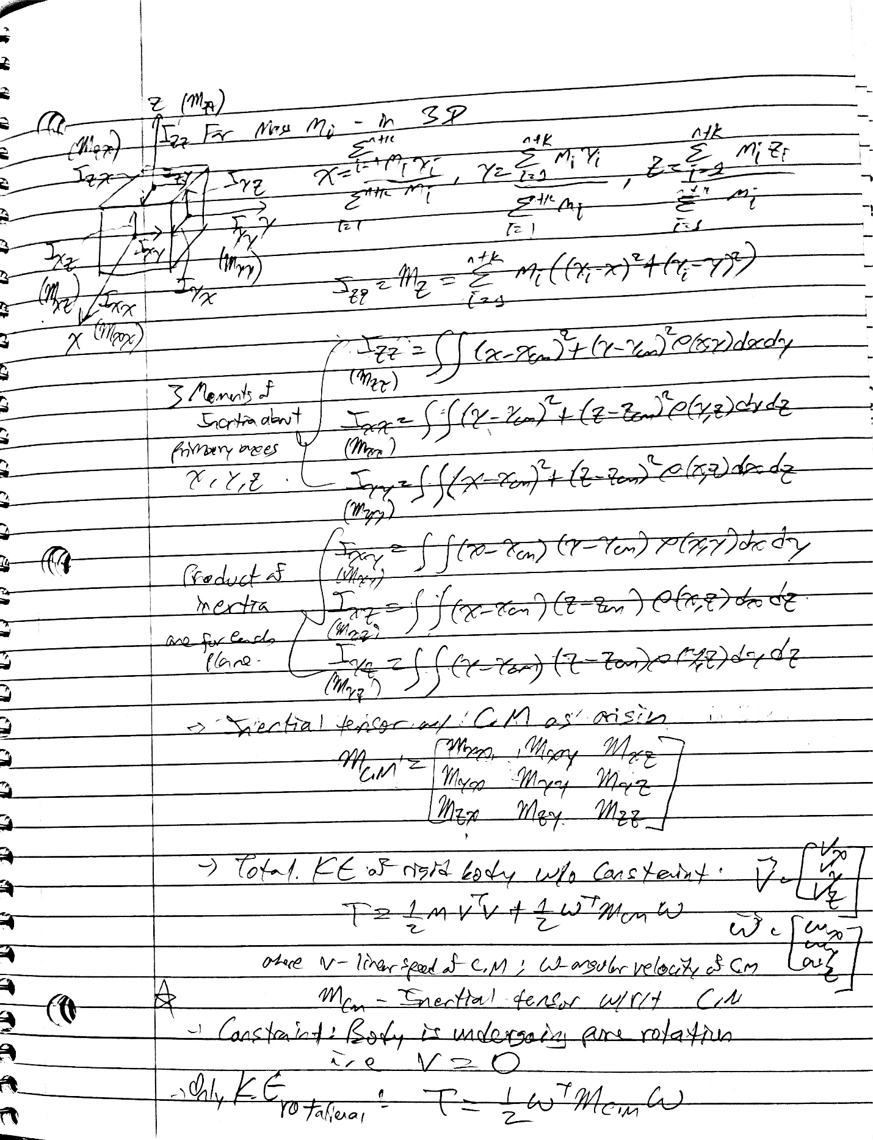

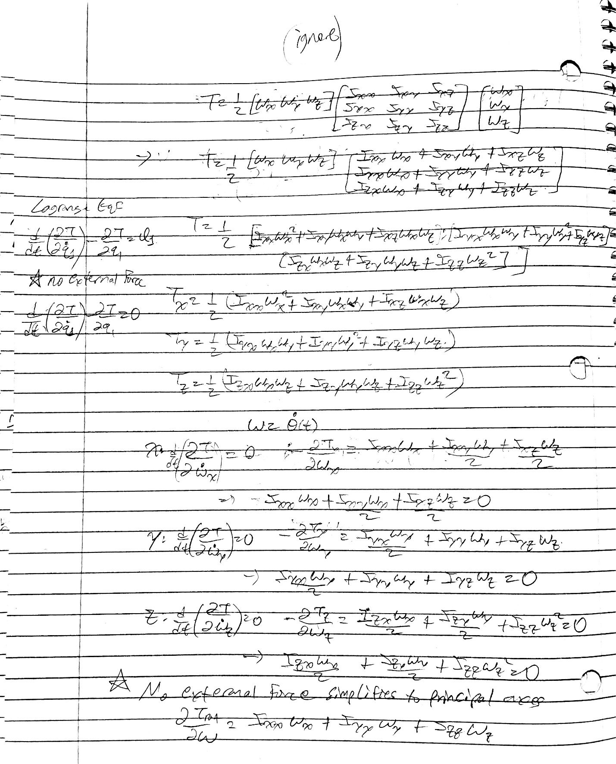

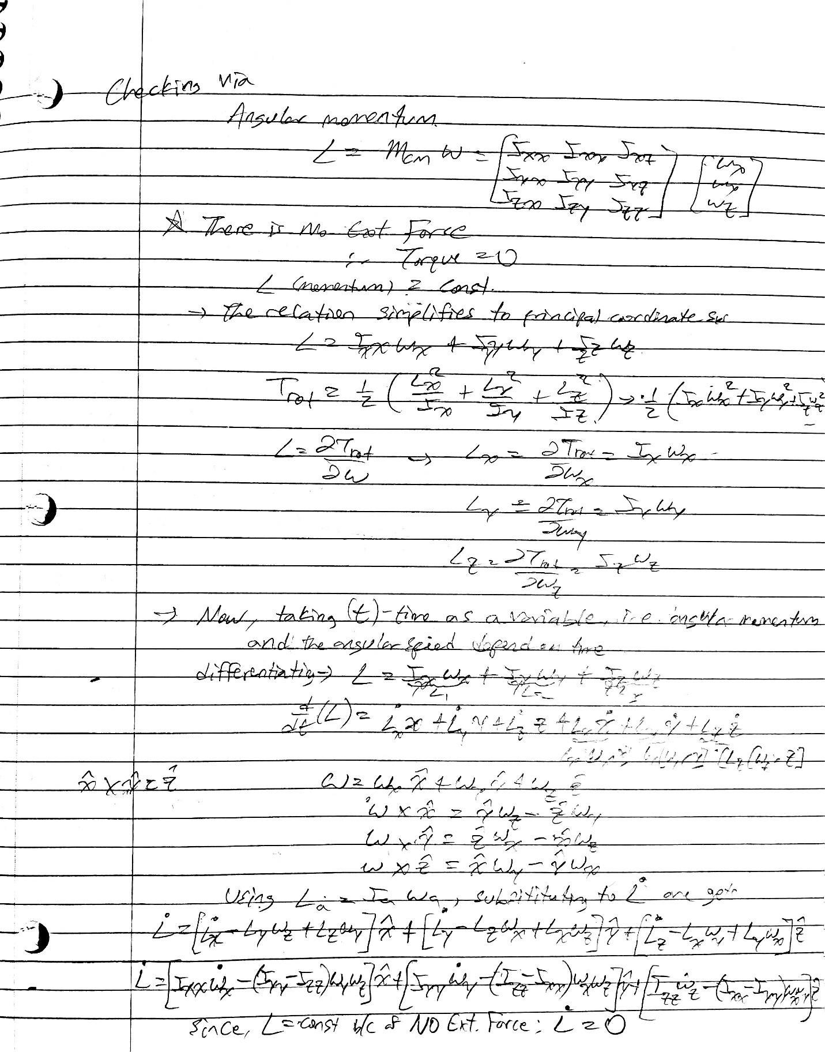

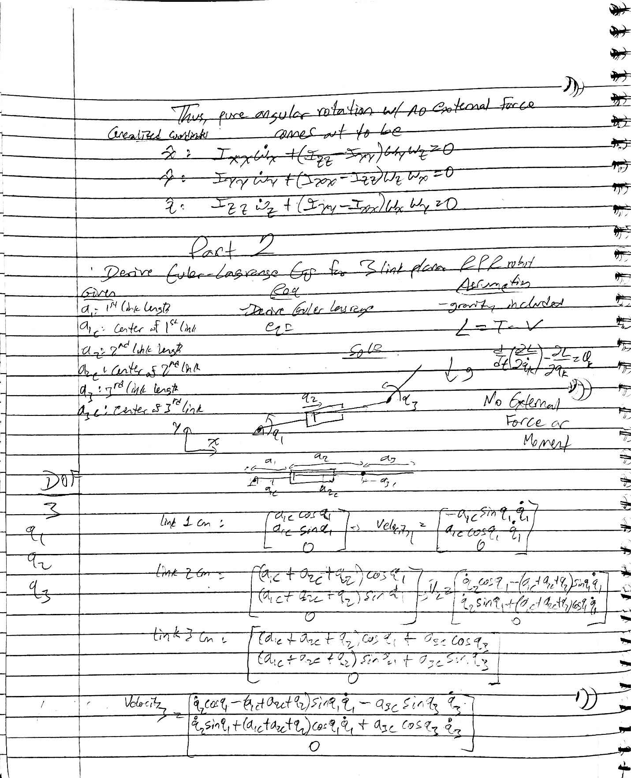

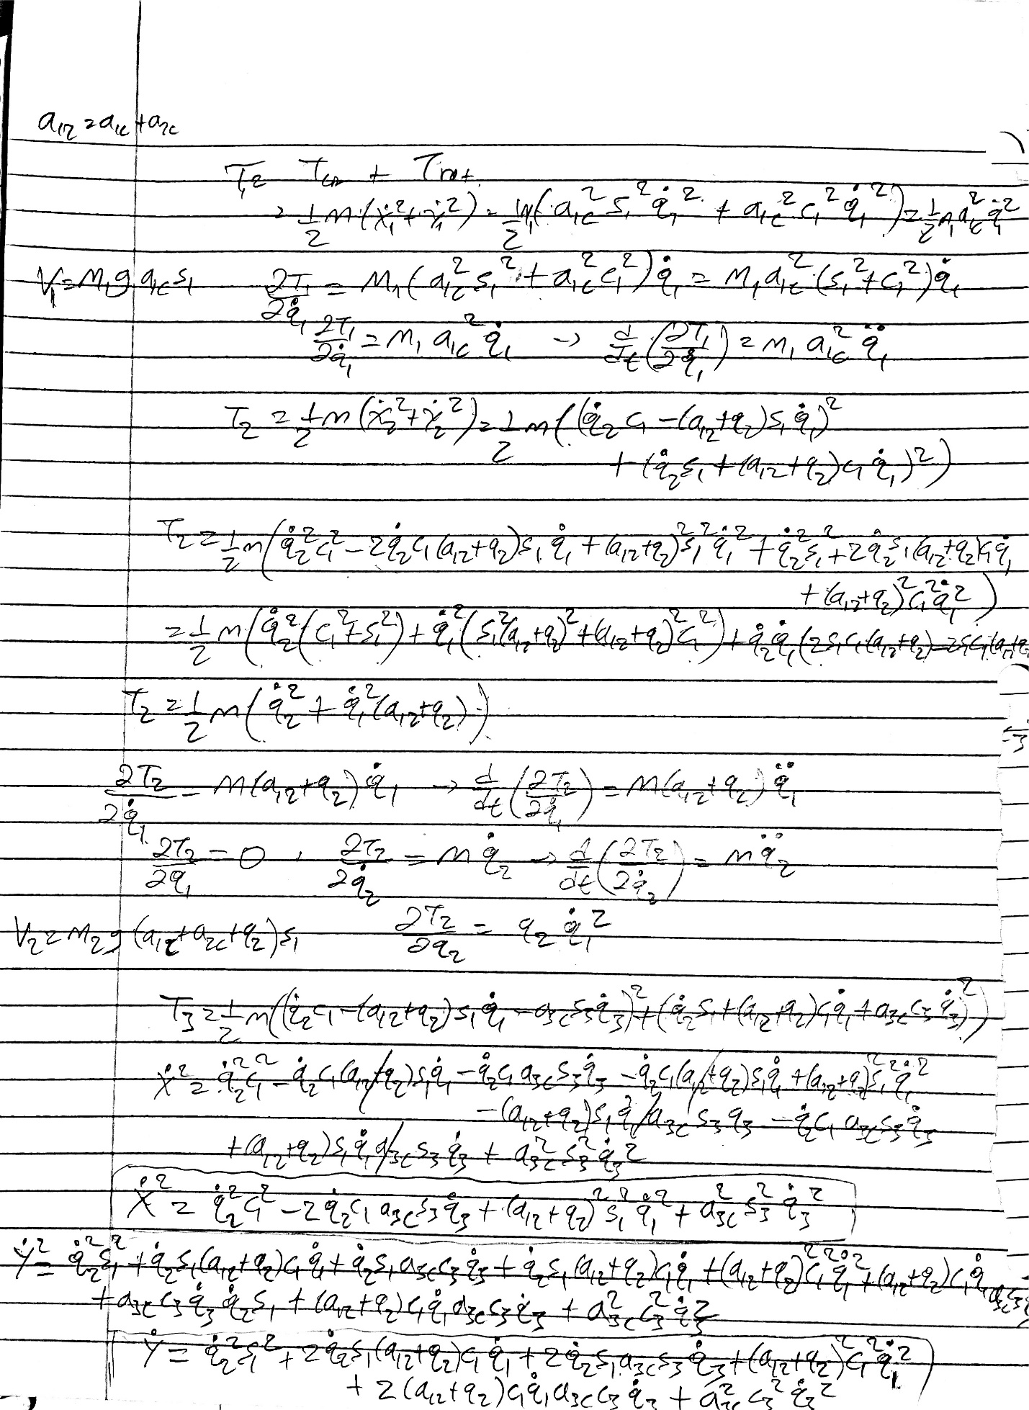

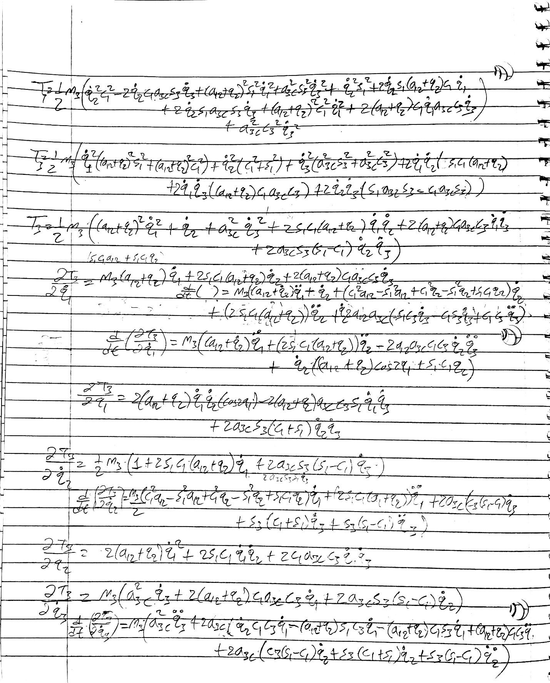

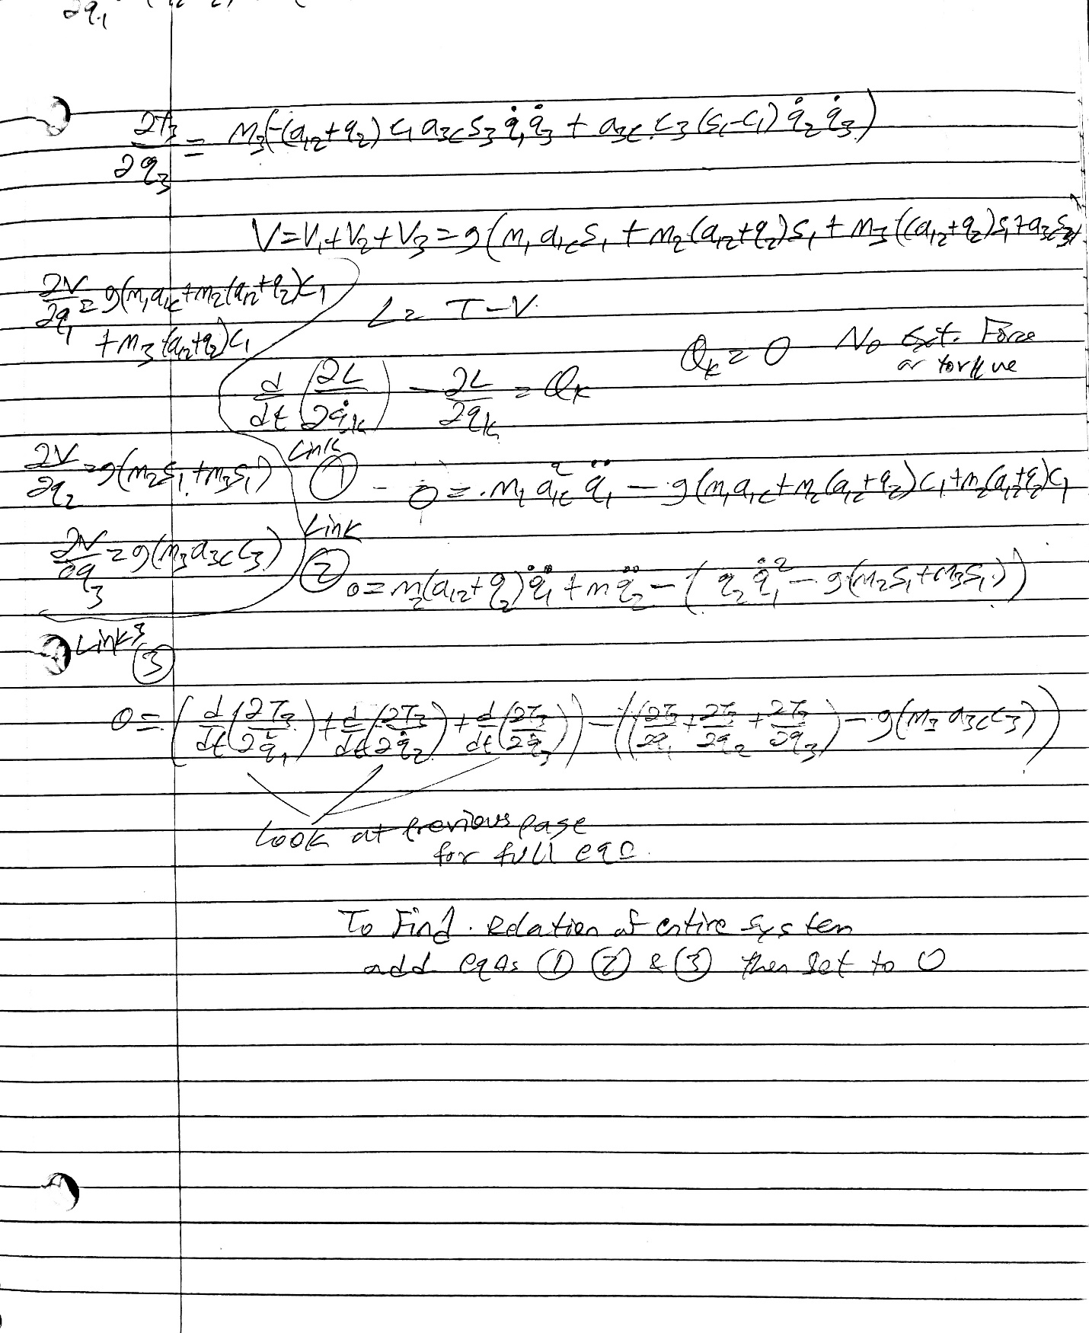

**4. Summary of Research**

**Dynamic Identification of the KUKA LBR iiwa Robot With Retrieval of Physical Parameters Using Global Optimization**

Tian et al’s paper on dynamic identification of a robotic manipulator got its basis from robotic applications that work in solving robot motion, human robot interactions and collision detection mechanisms. Because all of these activities deal with controlling the robot with accurate precision there became a need to develop a much more robust technique that can predict joint torques, for example to validate accuracy. So far researchers have linearized dynamic models to identify inertia parameters, to deal with singularities, avoid noise and the like. In this paper, however, Tian et al attempt to add universally global optimization framework that account for parametric bounds and constraints in addition to calculating objective error. Approach used was to measure joint positions and torques with filters applied to reduce noise. Then relative standard deviations were used to weigh contribution of parameters to dynamics model. Finally, saved parameters were used to calculate objective function. Although improvements were seen to limit error in computing joint position and torque, the bounds used were not strictly accurate which limited the resolution of obtaining true physical parameters, thus more work need to be done to support claim. The work initiated in this paper has been used as a starting point for other research that try to identify, for example, dynamics of 7 DoF robotic manipulator via population-based meta-heuristics[2], and setting up coordinate measurement system for links in a robot via pull wire sensor[3].

**Improving the Absolute Positioning Accuracy of Robot Manipulators**

Industrial robots need to be accurate when tasked to move items from one place to another, and at sites performing repetitive tasks. Hence, position accuracy is vital when robots are instructed to reach a given position. So far, the approaches used to characterize joint positioning such as DH method that use homogenous transformations to control serially linked manipulators have been found to have deficiencies for parallel consecutive joint axis. Whereas Mooring uses parametric identification techniques along with rotation unit vectors, although the parameters might not be consistently using with the control algorithm. Thus, Hayati and Mirmirani proposed to set tolerances for link parameter thereby increasing end effector positioning algorithm. First, error sources of transformation computations from each link were mapped to a common frame through use of error vector. Then, by assuming consecutive links as non parallel, transformation matrixes were computed upon which error equation between frames were computed relating nominal and actual transformations, which were then mapped to the robots base frame. For near parallel links, a plane was introduced and rotated to identify errors between adjacent frames. When methodology was tested on Standard Arm and PUMA 560, there was a careful delineation between running the algorithm for near parallel and non-parallel links which as a result led to in accurate estimation when performing error calculations for the robots that had both alignment in a given configuration. Since publication of this paper, topics on accurately determining robot end effector position discussed here has been a springboard to works that use single camera and computer vision to reduce pose errors [4], and research that attempts to simultaneously calibrate kinematic parameters of robot as well as robot mounted measurement devices[5], all aiming to reduce the error of moving robot end effector to specific location.

**Reference**

*[1] Agarwal, Siddharth*. All things about robotics and computer vision. (January 26, 2020.). Retrieved December 12, 2022, from [https://medium.com/all-things-about-robotics-and-computer- vision/homography-and-how-to-calculate-it-8abf3a13ddc5#:~:text=Homography%20relates%20points%20in%20first,any%20affect%20on%20projective%20transformation](https://medium.com/all-things-about-robotics-and-computer-%20vision/homography-and-how-to-calculate-it-8abf3a13ddc5#:~:text=Homography%20relates%20points%20in%20first,any%20affect%20on%20projective%20transformation).

[2] Eduardo G. Ribeiro, Raul Q. Mendes, Marco H. Terra, Valdir Grassi, "Dynamic Parameter Identification of a 7-DoF Lightweight Robot Manipulator Using Probabilistic Differential Optimization", 2022 IEEE International Conference on Systems, Man, and Cybernetics (SMC), pp.1917-1923, 2022.

[3] Shuang Gao, Kaiwei Ma, Yang Gao, Xin Shen, Mingxing Yang, Fengyu Xu, "A Robot Coordinate Measurement System Based on Pull Wire Sensor and Its Parameter Identification Method", 2022 12th International Conference on CYBER Technology in Automation, Control, and Intelligent Systems (CYBER), pp.514-519, 2022.

[4] Hamid Majidi Balanji, Ali Emre Turgut, Lutfi Taner Tunc, A novel vision-based calibration framework for industrial robotic manipulators, Robotics and Computer-Integrated Manufacturing, 10.1016/j.rcim.2021.102248, 73, (102248), (2022).

[5] Mohammadreza Dehghani, Ryan A. McKenzie, Rishad A. Irani, Mojtaba Ahmadi, Robot-mounted sensing and local calibration for high-accuracy manufacturing, Robotics and Computer-Integrated Manufacturing, 10.1016/j.rcim.2022.102429, 79, (102429), (2023).